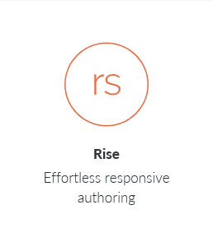**HOW-TO for Learning Journal in Rise**

**WHAT IS A LEARNING JOURNAL?**

The Learning Journal allows a learner to enter text responses to journal prompts throughout a Rise course. At the end of the course, the learner can print their learning journal of all their responses. The responses are saved to the browser so that they persist on future visits to the Rise course.

To see an example of a Rise course with the learning journal, visit http://amelangrise.s3.amazonaws.com/learningjournal/index.html

For more information, visit the github project at

https://github.com/mikeamelang/learning-journal

**HOW DOES THE DEVELOPER ADD JOURNAL PROMPTS?**

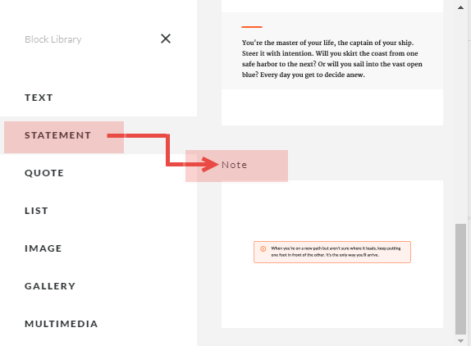From the STATEMENT section, add a new block of type NOTE.

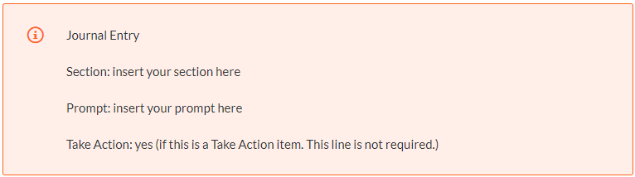Enter the following into the Note. If the labels are not entered exactly correct, the Journal Entry will fail. Take Action items are special journal entries that can be printed separately.

**HOW TO ADD AN INTRO TO A SECTION ON THE PRINTED JOURNAL?**

From the STATEMENT section, add another new block of type NOTE.

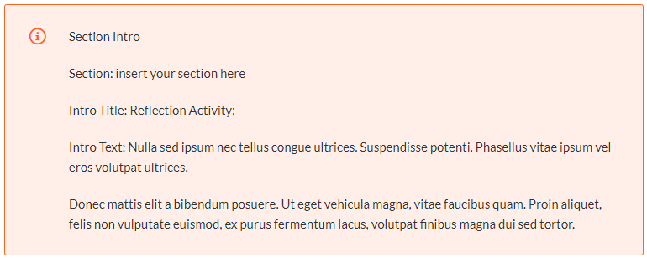Enter the following into the Note. The location of this Note does not matter. All Journal Entries that are labeled with this Section will be printed together with this Section Intro.

**HOW TO ADD PRINT BUTTONS OR PROVIDE A CUSTOM TITLE TO THE LEARNING JOURNAL?**

From the STATEMENT section, add another new block of type NOTE.

Enter the following into the Note. The print buttons will appear at this location in the course.

**DOES THE DEVELOPER HAVE TO DO ANYTHING ELSE?**

Yes! The Rise output must be customized.

1. Install the free application Notepad++ found at <https://notepad-plus-plus.org/>
2. After outputting the Rise course and before uploading the outputted files to your server or LMS, open the index.html file using Notepad++ (The index.html file is sometimes found in the scormcontent folder.)
3. Find the below line in the index.html (possibly line 12):

<script type="text/javascript" src="lib/player-0.0.11.min.js"></script>

1. Paste the following lines after the above line. Then save index.html.

<script src="https://ajax.googleapis.com/ajax/libs/jquery/3.3.1/jquery.min.js"></script>

<link type="text/css" rel="stylesheet" href="Nordstrom.css">

<script src="Nordstrom.js"></script>

1. Copy these two files into the same folder as the index.html file

* Nordstrom.js
* Nordstrom.css